CSA1735- ARTIFICIAL INTELLIGENCE
CO1 ASSESSMENT 1: ANALYTICAL PROBLEM SOLVING

Virupaksha Praveen (192417007)

QUESTION 1: Bridge and Torch Problem (State-Space + Uniform Cost Search)

Definition

Four people must cross a bridge at night. The bridge holds at most 2 people at a time, and they need the single torch. A pair walks at the speed of the slower person. The goal is to get everyone across in the minimum total time. It is a classic state-space search problem solved with Uniform Cost Search (UCS).
Crossing times: A = 1, B = 2, C = 5, D = 10 minutes.

Problem Formulation

Component | Description
State | (people on Left bank, people on Right bank, torch side)
Initial state | ({1,2,5,10}, { }, Torch = Left)
Goal state | ({ }, {1,2,5,10}, Torch = Right)
Actions | Move 1 or 2 people (on the torch side) across with the torch
Path cost | Time of a crossing = max of the walking times of those crossing; total cost = sum
Goal test | Left bank is empty
State space size | Each person is Left/Right (2⁴ = 16) × torch side (2) = at most 32 states

Algorithm (UCS)

    - Put the initial state in the frontier (priority queue ordered by g) with g = 0.
    - If the frontier is empty, report failure.
    - Remove the node with the lowest g from the frontier.

    - If it passes the goal test, return the solution.
    - Add it to the explored set.
    - Generate all successors. For each one, g = g(parent) + crossing time.
    - Insert a successor if it is new, or replace the old entry if it has a lower g. Ignore it if it is already explored.
    - Go to step 2.

Diagram: Optimal Path in the State Space
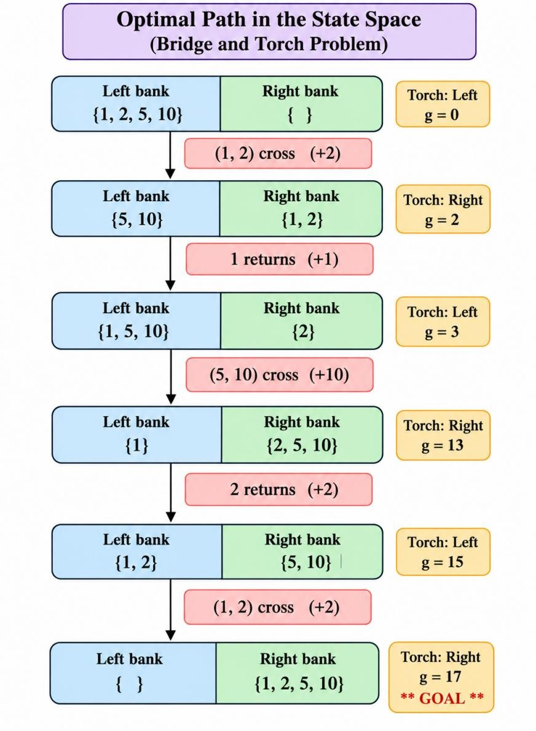

Example and Step-by-Step Solution

- UCS expansion trace (nodes popped in order of g)

Step | Node expanded (g) | Successors generated (g)
1 | [1,2,5,10 | –] L (0) | [5,10|1,2]R 2; [2,10|1,5]R 5; [1,10|2,5]R 5; [2,5|1,10]R 10;  [1,5|2,10]R 10; [1,2|5,10]R 10
2 | [5,10|1,2] R (2) | 1 returns → [1,5,10|2]L 3; 2 returns → [2,5,10|1]L 4
3 | [1,5,10|2] L (3) | (1,5) → [10|1,2,5]R 8; (1,10) → [5|1,2,10]R 13; (5,10) →  [1|2,5,10]R 13
4 | [2,5,10|1] L (4) | (2,5) → [10|1,2,5]R 9 ✗ (8 already better); (2,10) → [5|1,2,10]R  14 ✗; (5,10) → [2|1,5,10]R 14
5 | [2,10|1,5] R (5) | 1 returns → [1,2,10|5]L 6; 5 returns → worse, discarded
6 | [1,10|2,5] R (5) | 2 returns → [1,2,10|5]L 7 ✗ (6 already better)
7 | [1,2,10|5] L (6) | (1,2) → [10|1,2,5]R 8 (tie, no change); others cost 16 ✗
8 | [10|1,2,5] R (8) | 1 returns → [1,10|2,5]L 9; 2 returns → [2,10|1,5]L 10; 5 returns  → [5,10|1,2]L 13
9 | [1,10|2,5] L (9) | (1,10) crosses → goal found with g = 19 (not yet popped)
10 | States with g = 10 to 14 | Only cheaper route found: [1,2,5|10]L (11) → [5|1,2,10]R (13); [1,5|2,10]L (14) → goal 19. None beats 17
11 | [1,2|5,10] L (15) | (1,2) crosses → Goal with g = 17
12 | Goal (17) popped | UCS stops. Optimal cost = 17

Crossing sequence and total time

Trip | Who moves | Direction | Time | Running total
1 | 1 and 2 | Left → Right | max(1,2  ) = 2 | 2
2 | 1 (with torch) | Right → Left | 1 | 3
3 | 5 and 10 | Left → Right | max(5,1 0) = 10 | 13
4 | 2 (with torch) | Right → Left | 2 | 15
5 | 1 and 2 | Left → Right | max(1,2  ) = 2 | 17
Minimum total time = 2 + 1 + 10 + 2 + 2 = 17 minutes.

Comparison with the obvious strategy

Strategy | Calculation | Total
Fastest person escorts everyone | 2 + 1 + 5 + 1 + 10 | 19
Optimal (the two slowest cross together) | 2 + 1 + 10 + 2 + 2 | 17
The two slowest people (5 and 10) cross together, so the 10-minute cost is paid only once.

Pseudocode
function UCS(problem):
node ← (state = problem.INITIAL, g = 0, parent = NULL) frontier ← priority queue ordered by g, containing node explored ← empty set
loop:
if frontier is empty: return FAILURE node ← frontier.POP_LOWEST_g()
if problem.GOAL_TEST(node.state): return SOLUTION(node) add node.state to explored
for each action in problem.ACTIONS(node.state):

child.state ← RESULT(node.state, action)
child.g ← node.g + STEP_COST(node.state, action) if child.state not in explored and not in frontier:
frontier.INSERT(child)
else if child.state in frontier with higher g: replace that entry with child

Conclusion

The Bridge and Torch problem is modelled as a state-space search with the torch side included in the state and the crossing time as the action cost. UCS expands the cheapest state first and finds the optimal plan (1,2 → 1 back → 5,10 → 2 back → 1,2) with a minimum total time of 17 minutes.

QUESTION 2: Route Finding using A* Search

  - Definition

A* is an informed search algorithm. It expands the node with the lowest

f(n) = g(n) + h(n)

where g(n) is the actual cost so far and h(n) is a heuristic estimate of the remaining cost. It combines UCS (uses g) and greedy search (uses h).

Problem Formulation

Component | Description
State | A node (city/junction)
Initial state | S
Goal state | G
Actions | Travel along a road (edge) to a neighbouring node
State space | The graph's nodes: {S, A, B, C, D, G}

Path cost | Sum of edge costs
Goal test | n = G

Algorithm

    - Put the start node in OPEN with g = 0 and f = h(start).
    - Repeat while OPEN is not empty.
    - Remove from OPEN the node n with the lowest f(n).
    - If n is the goal, stop and return the path (follow parent links).
    - Move n to CLOSED.
    - For each neighbour m of n, compute g(m) = g(n) + cost(n,m) and f(m) = g(m) + h(m).
    - If m is in CLOSED, skip it. If m is in OPEN with a larger g, update its g, f and parent. If m is new, add it to OPEN.
    - Go to step 2.
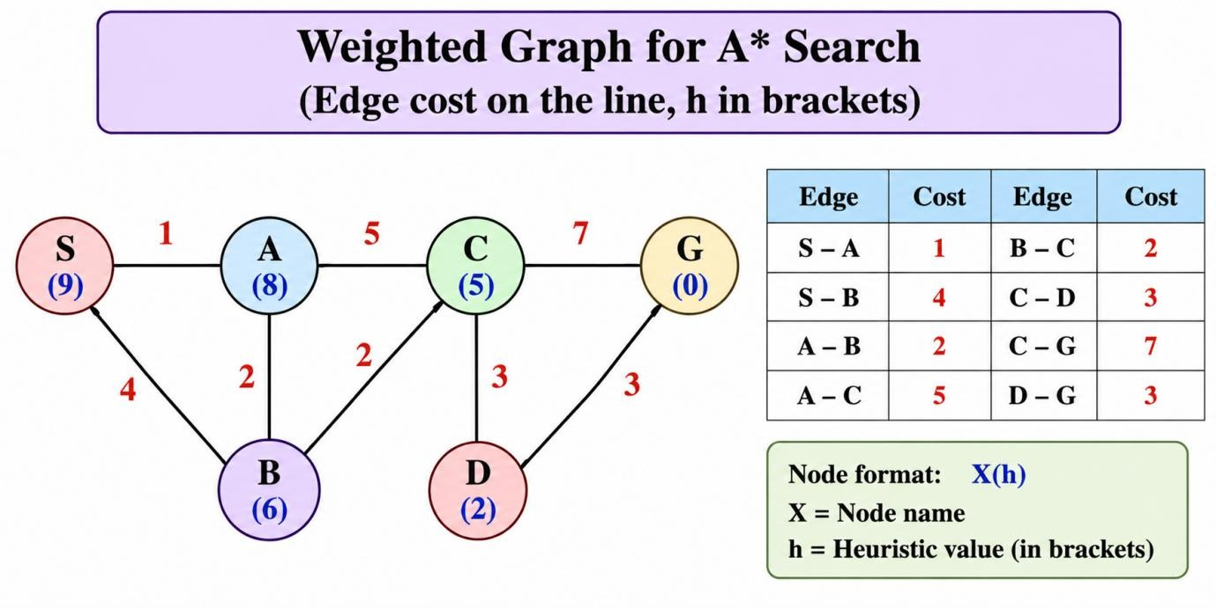
Node S A B C D G h(n) 9 8 6 5 2 0
Check of h (true remaining cost h*): S = 11, A = 10, B = 8, C = 6, D = 3, G = 0. Every h(n)
≤ h*(n), so h is admissible.

Step-by-Step Solution

Ste p | Expanded node |  | Neighbours: g, h, f |  | OPEN after step (f) | CLOSED
1 | S (f = 9) |  | A: g = 1, h = 8, f = 9; B: g = 4, h = 6, f = 10 |  | A(9), B(10) | S
2 | A (f = 9) |  | B: g = 1+2 = 3, h = 6, f = 9 (better than 4,  update); C: g = 1+5 = 6, h = 5, f = 11 |  | B(9), C(11) | S, A
3 | B (f = 9) |  | C: g = 3+2 = 5, h = 5, f = 10 (better than 6, update) |  | C(10) | S, A, B
4 | C (f = 10) |  | D: g = 5+3 = 8, h = 2, f = 10; G: g = 5+7  = 12, h = 0, f = 12 |  | D(10), G(12) | S, A, B, C
5 | D (f = 10) |  | G: g = 8+3 = 11, h = 0, f = 11 (better than 12, update) |  | G(11) | S, A, B, C, D
6 | G (f = 11) |  | Goal reached |  | – | –
Summary table of final values
Node | g(n) | h(n) | f(n) = g + h | Best parent
S | 0 | 9 | 9 | –
A | 1 | 8 | 9 | S
B | 3 | 6 | 9 | A
C | 5 | 5 | 10 | B
D | 8 | 2 | 10 | C

G 11 0 11 D

Expansion order: S → A → B → C → D → G
Final path: S → A → B → C → D → G, cost = 1 + 2 + 2 + 3 + 3 = 11

Other paths are costlier: S-A-C-D-G = 12, S-B-C-D-G = 12, S-A-C-G = 13.

Pseudocode
function A_STAR(start, goal):
OPEN ← priority queue ordered by f; insert start with g = 0, f = h(start)
CLOSED ← empty set while OPEN is not empty:
n ← OPEN.POP_LOWEST_f()
if n = goal: return PATH(n) add n to CLOSED
for each neighbour m of n with edge cost c(n,m): g_new ← g(n) + c(n,m)
if m in CLOSED: continue
if m not in OPEN or g_new < g(m): g(m) ← g_new
f(m) ← g(m) + h(m) parent(m) ← n
OPEN.INSERT_OR_UPDATE(m)
return FAILURE

When Is A* Optimal?

A* guarantees an optimal solution when:

    - h is admissible: h(n) ≤ true cost to the goal (it never overestimates). This is enough for tree search.
    - For graph search with a CLOSED list, h should be consistent: h(n) ≤ c(n,n′) + h(n′).
    - All edge costs are positive, and the branching factor is finite.

In our graph h is consistent. For example, h(A) = 8 ≤ cost(A,B) + h(B) = 2 + 6 = 8. Special case: h = 0 makes A* identical to UCS.

Advantages and Limitations
Advantages Limitations

Optimal if h is admissible/consistent Quality depends on a good heuristic

Complete on finite graphs with positive costs
Stores all generated nodes, so memory heavy

Expands fewer nodes than UCS (guided by h)
Time can still be exponential in the worst case

Widely used (maps, games, robots) A bad (overestimating) h can lose optimality

Conclusion

A* ranks nodes by f(n) = g(n) + h(n). In the example it expanded S, A, B, C, D, G and returned the optimal route S-A-B-C-D-G with cost 11. Optimality is guaranteed when the heuristic is admissible (and consistent for graph search).

QUESTION 3: Smart Traffic Signal Controller (Intelligent Agent)

  - Definition

An intelligent agent perceives its environment through sensors and acts on it through actuators to achieve goals. A Smart Traffic Signal Controller is an agent that senses vehicle queues at a junction and changes the signals to reduce waiting time while staying safe.

Problem Formulation (PEAS Description)

Assumed junction: a 4-way crossing with approaches N, S, E, W and two phases: NS-green and EW-green.

PEAS Description

Percepts Queue length on each approach, waiting time, current phase and timer, emergency vehicle signal, pedestrian button press

Sensors Inductive loop detectors, cameras, pedestrian push-buttons, emergency-vehicle receiver, timer/clock

Environment Road junction with cars, buses, two-wheelers, pedestrians, emergency vehicles, and changing traffic and weather

Actions Keep the current green, extend green, switch phase, show yellow, all-red clearance, give pedestrian walk, give emergency priority

Actuators Red/yellow/green lamps, pedestrian signals, phase timer relays

Agent program Rule/utility-based decision logic (see pseudocode)

Architecture Controller hardware + sensors + actuators + software (internal state, decision module, safety checker)

Performance measures
Average waiting time ↓, queue length ↓, throughput ↑, number of stops
↓, zero conflicting greens, emergency response time ↓, fairness (no approach waits too long)

Environment properties: partially observable, stochastic (random arrivals), dynamic, sequential, continuous, with multiple agents (drivers and pedestrians).
Agent type: a model-based, utility-based agent. It keeps internal state (queues, phase timer) and picks the action that maximizes the utility "least delay, with safety".

Safety constraints (assumed example values): Constraint Value
Minimum green 10 s Maximum green 60 s Yellow 3 s
All-red clearance 2 s Conflicting greens never allowed

Algorithm (One Control Cycle)

    - Sense: read queue lengths N, S, E, W, pedestrian requests and emergency signals.

    - Update state: calculate demand for each phase: NS demand = N + S; EW demand = E + W.
    - Emergency check: if an emergency vehicle is detected, give its approach green (after yellow and all-red).
    - Min-green check: if the current green has run less than the minimum green, keep it.
    - Decide: if the other phase's demand ≥ 2 × the current phase's demand (or the max green has been reached), choose to switch.
    - Safety transition: show yellow (3 s), then all-red (2 s), then the new green.
    - Green time: green = 2 s × (largest queue on the new phase), limited to 10–60 s (assumed ≈ 2 s per vehicle).
    - Act: drive the lamps and repeat from step 1.

Diagram: Agent Architecture

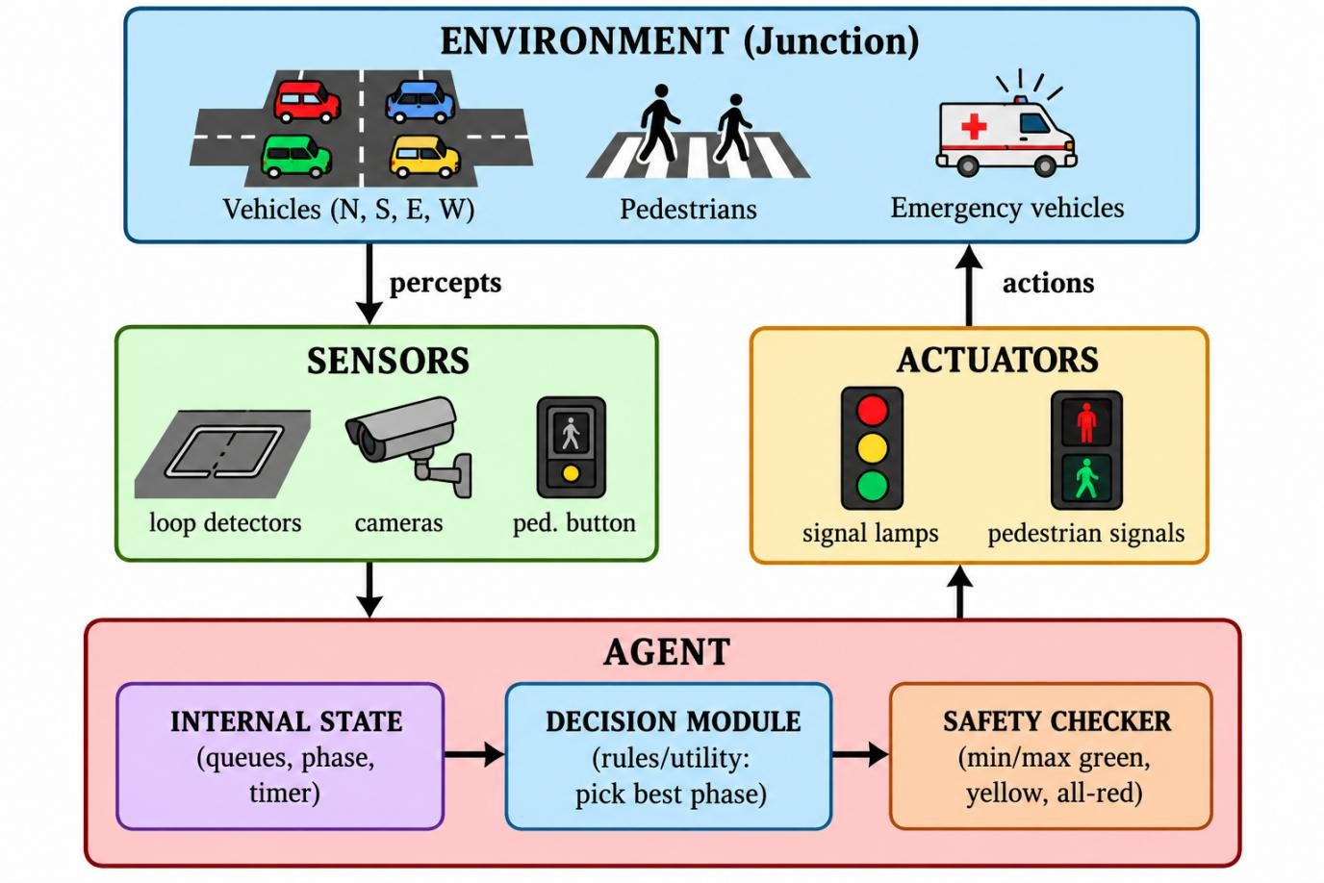

Example with Different Queue Lengths

Given: N = 12, S = 8, E = 3, W = 2 vehicles. The current phase is EW-green, already running for 15 s (above the 10 s minimum).

Quantity Calculation Value

NS demand | 12 + 8 | 20
EW demand | 3 + 2 | 5
Switch rule | 20 ≥ 2 × 5 = 10 ✓ and min green is done | Switch to NS
Safety sequence | EW yellow 3 s + all-red 2 s | 5 s
NS green time | 2 s × 12 (largest queue, N) = 24 s, within 10–60 | 24 s
Next EW green | 2 s × 3 (E) = 6 s, raised to the minimum | 10 s

Adaptive cycle length = (24 + 3 + 2) + (10 + 3 + 2) = 44 s
Fixed-time cycle (30 s green each) = 2 × (30 + 3 + 2) = 70 s

In the fixed plan, EW would hold green for 30 s although 3 cars need only about 6 s. That wastes about 24 s while 20 vehicles wait on N and S.

Pseudocode
function TRAFFIC_AGENT(percept):
state ← UPDATE_STATE(state, percept) // queues, phase, timers if state.in_transition: // yellow / all-red running
return CONTINUE_TRANSITION()
if percept.emergency on approach X:
return PRIORITY_PHASE(X) // after yellow + all-red if state.green_elapsed < MIN_GREEN:
return KEEP_CURRENT()
demand_cur ← queue sum of current phase demand_other ← queue sum of other phase
if state.green_elapsed >= MAX_GREEN or demand_other >= 2 * demand_cur: return START_YELLOW_THEN_SWITCH()
if percept.pedestrian_request and safe: return PEDESTRIAN_PHASE()
return KEEP_CURRENT()

// when a new green starts:
green_time ← CLAMP(2 * max_queue_of_new_phase, MIN_GREEN, MAX_GREEN)

How It Improves Flow While Staying Safe

- It gives longer green to heavy queues and shorter green to light ones, so less time is wasted.
- It never turns two conflicting directions green together. The yellow and all-red intervals are fixed and cannot be skipped.
- Minimum green stops unsafe flickering. Maximum green stops starvation, so every approach gets service.
- Emergency and pedestrian requests are handled with priority, but only through the safe transition sequence.

Advantages and Limitations
Advantages Limitations

Adapts to real-time traffic and cuts waiting time
Needs sensors, which can fail or give noisy data

Reduces fuel use and emissions (fewer stops)
Costly to install and maintain

Handles emergency vehicles and pedestrians
Rule thresholds (e.g. 2×) must be tuned

Safety rules are built in Local view only, unless junctions are coordinated

Conclusion

The smart traffic controller is a model-based, utility-based agent. It senses queue lengths, updates its internal state, selects the best phase and passes the decision through a safety checker before actuating the lamps. In the example, it switched to NS (demand 20 vs 5) and reduced the cycle from 70 s to 44 s without breaking any safety rule.

QUESTION 4: Mars Rover Agent

  - Definition

A Mars Rover agent is an autonomous robotic agent that senses the Martian surface with sensors and acts with wheels, arms and instruments to explore safely, save energy, and collect and send scientific data.

Problem Formulation (PEAS)
PEAS Description

Percepts Camera images of terrain, obstacle distance, tilt/slope angle, wheel slip, battery level, temperature, sunlight/time of day, sample readings, commands from Earth

Sensors Stereo cameras, obstacle/range sensor, tilt sensor (IMU), wheel encoders, temperature sensors, battery sensor, sun sensor, science instruments (e.g. spectrometer), radio receiver

Environment Mars surface: rocks, sand, slopes, craters, dust, low temperature. It is partially observable, dynamic, stochastic and continuous, with a long communication delay to Earth

Actions Move forward, turn, stop, reverse, re-plan route, capture image, deploy arm, drill/scoop, analyse sample, charge/sleep, transmit data

Actuators Wheel and steering motors, robotic arm, drill, camera mast motor, antenna, heaters, transmitter

Performance measure
Science data collected and sent ↑, area explored ↑, safety (no collision, tip-over or getting stuck), energy efficiency, mission lifetime ↑

Decision priorities: (1) safety, (2) energy and survival, (3) science goals.

Algorithm (Rover Control Loop)

    - Sense: read cameras, tilt, battery, temperature and the current goal.
    - Perceive: build or update a map of obstacles and safe cells.
    - Safety reflex: if an obstacle is within the stop distance or the tilt exceeds its limit, stop immediately.
    - Energy check: if battery < reserve level, go to charge/sleep mode and skip science tasks.
    - Plan: find the lowest-cost safe path to the target (e.g. A* with obstacles and unsafe slopes blocked).
    - Act: move one step along the path, or run the science task if at the target.
    - Record and transmit: store data and send it to Earth when the link is available.
    - Repeat from step 1.

Diagram: Agent Architecture

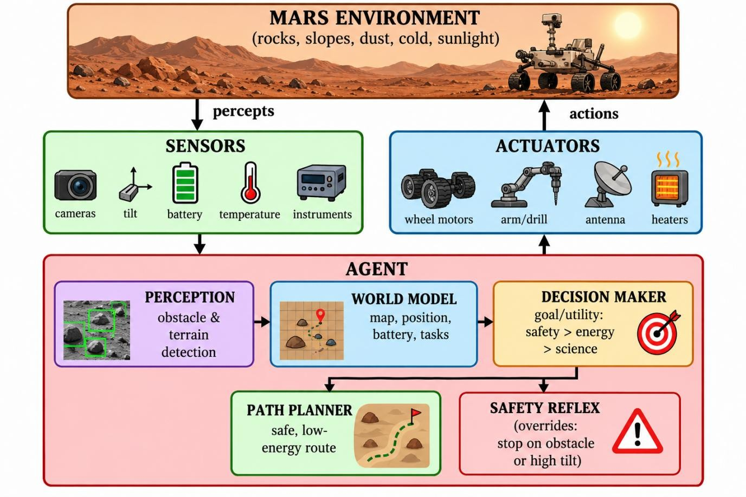
Earth link: receive commands / send data <--> COMMUNICATION MODULE

Example: Obstacle Detection and Safe Route

Assumptions (illustration only): the map is a grid of 1 m cells and a move costs 1 energy unit per cell. Row y = −1 is a steep slope (unsafe). The rover starts at R(0,0) and the sample site is G(4,0).
y=+1 *-----* *
| |
y= 0 R-----* [X] * G
y=-1 /// steep slope (unsafe) /// x=0 x=1 x=2 x=3 x=4

- is the boulder at (2,0), detected by the camera while the rover is at (1,0).

Decision steps

Step Rover decision Reason

  - Detect boulder at (2,0), straight path blocked Obstacle percept

  - Stop Safety reflex

  - Reject the route via y = −1 Slope is above the safe limit

  - Plan the route via y = +1 Only safe detour

  - Path: (0,0) → (1,0) → (1,1) → (2,1) → (3,1) → (3,0) →
(4,0)
Avoids the obstacle

Cost: the blocked straight route would cost 4 units. The safe route costs 6 units, which is 2 extra units for safety. No safe route can be shorter than 6, because the shortest possible path
(4) is blocked and any detour needs at least 2 extra moves. The rover also checks that battery after the trip ≥ reserve level before moving.

Pseudocode
function MARS_ROVER_AGENT(percept):
state ← UPDATE_MODEL(state, percept) // map, position, battery
if percept.obstacle_distance < STOP_DIST or percept.tilt > TILT_LIMIT: return STOP // safety reflex
if state.battery < RESERVE: return CHARGE_OR_SLEEP
if state.at_target:
return DO_SCIENCE_TASK() // image, drill, analyse, store
path ← A_STAR(state.position, state.goal, avoid = obstacles + unsafe_slopes) if path = FAILURE:
return REQUEST_HELP_FROM_EARTH()
if state.data_ready and state.link_available: return TRANSMIT_DATA
return NEXT_STEP(path)

Key Capabilities Explained

- Decision-making: a goal/utility-based choice that ranks safety first, then energy, then science value.
- Obstacle avoidance: the camera and range sensors detect obstacles, the reflex layer stops the rover, and the planner finds a safe detour.

- Energy efficiency: it chooses low-cost routes, avoids needless movement, charges when the battery is low, and schedules heavy tasks when power is available.
- Scientific data collection: it positions itself at targets, uses the arm and instruments, stores results and transmits them to Earth.

Why an Autonomous Agent Is Useful on Mars

- Communication delay: signals take several minutes (the one-way time changes with planet positions), so live remote control is not practical.
- It must react immediately to dangers such as obstacles, steep slopes and low power.

Mars is too dangerous and distant for humans.
- The rover can keep working between the commands sent from Earth, so more science gets done.
- It handles unexpected situations locally, protecting an expensive mission.

Advantages and Limitations
Advantages Limitations

Works without continuous human control Limited computing power and energy Safer navigation through obstacle avoidance Sensors can be noisy or blocked by dust Explores more area and collects more data Cannot be physically repaired
Saves energy through planning Unpredictable terrain can cause failures

Conclusion

The Mars Rover is an autonomous, goal/utility-based agent with a layered architecture: sensors → perception → world model → decision maker → planner and safety reflex → actuators. It puts safety first, conserves energy and collects science data. In the example it detected a boulder, stopped, rejected the unsafe slope and followed a safe 6-unit detour to the goal. Autonomy is essential because Earth-to-Mars delays rule out real-time control.

QUESTION 4: Logistics Delivery Network (Uniform Cost Search)

Definition
A logistics delivery network consists of a central depot, warehouses, and customer delivery points connected by roads. Each road has a travel cost, represented here in kilometres. The objective is to find the route from the depot to the destination with the minimum total travel cost. Uniform Cost Search (UCS) is suitable because it always expands the frontier node with the lowest accumulated path cost.

Problem Statement
A delivery vehicle must travel from the Central Depot (S) to the Customer Hub (G). The available routes and their distances are shown below. Use Uniform Cost Search to determine the minimum-cost route.

Network Data
Road / Connection | Travel Cost
S – A | 2 km
S – B | 5 km
A – C | 2 km
A – D | 4 km
B – D | 1 km
C – D | 1 km
C – G | 5 km
D – G | 3 km

Problem Formulation
Initial state: | Central Depot S
Goal state: | Customer Hub G
Actions: | Move along any road connecting the current location to a neighbouring location
Step cost: | Distance of the selected road in kilometres
Path cost g(n): | Sum of the road distances from S to node n
Goal test: | Check whether the node removed from the priority queue is G

Uniform Cost Search (UCS) Algorithm
- Place the initial state S in a priority queue with path cost g(S) = 0.
- Remove the node with the smallest accumulated cost from the priority queue.
- If the removed node is the goal G, stop and return the route and its total cost.
- Otherwise, expand the node and calculate the cost of each neighbouring route: new cost = current cost + road cost.
- Add a new state to the queue, or update it if a cheaper route to that state has been found.
- Repeat until the goal is removed from the queue or the queue becomes empty.

Network Diagram
S (Depot) ──2── A ──2── C ──1── D ──3── G (Customer Hub)
│ │
└──5── B ───────1─────────┘
A ─────4───── D
C ─────5───── G

Step-by-Step Solution Using UCS
UCS expands the location with the lowest accumulated cost, not necessarily the location that is geographically closest to the destination.
Step | Expanded Node | Accumulated Cost g(n) | Action / Result
1 | S | 0 | Add A with cost 2 and B with cost 5.
2 | A | 2 | Add C with cost 2 + 2 = 4 and D with cost 2 + 4 = 6.
3 | C | 4 | Improve D to cost 4 + 1 = 5; add G with cost 4 + 5 = 9.
4 | B | 5 | Route to D through B costs 5 + 1 = 6, so keep the cheaper cost 5 already found for D.
5 | D | 5 | Add/improve G with cost 5 + 3 = 8, which is cheaper than 9.
6 | G | 8 | The goal is removed from the priority queue. UCS stops; the minimum route cost is 8 km.

Optimal Route and Total Cost
The lowest-cost route found by UCS is:
S → A → C → D → G
Total cost = 2 + 2 + 1 + 3 = 8 km

Verification
Route | Total distance
S → A → C → D → G | 2 + 2 + 1 + 3 = 8 km
S → A → D → G | 2 + 4 + 3 = 9 km
S → B → D → G | 5 + 1 + 3 = 9 km
S → A → C → G | 2 + 2 + 5 = 9 km

Result
Uniform Cost Search identifies S → A → C → D → G as the optimal delivery route, with a total travel distance of 8 km. UCS guarantees an optimal solution when all road costs are non-negative, as they are in this network.

Conclusion
This example demonstrates how Uniform Cost Search can be applied to a logistics delivery network. By maintaining a priority queue ordered by cumulative route cost, UCS explores cheaper routes before more expensive ones and returns the minimum-cost route to the customer hub.

Complexity
The time and memory requirements depend on the number of locations and connections in the network. UCS may store many frontier states; for this small example, the priority queue makes it straightforward to compare the cumulative costs and select the least-cost route.

